S. No. | QUESTION
1 | What is a PN junction diode.
PN junction diode is a two-terminal semiconductor device that is used for allowing electric current in one direction.
It has a positive (p) side and a negative (n) side created by adding impurities to each side of a silicon semiconductor.
2 | List the applications of PN junction diode.
- Rectification
- Signal demodulation
- Clipping
- Clamping
- LEDs
3 | Define the PIV of a PN junction diode.
A diode when connected in reverse bias, should be operated under a controlled level of voltage. If that safe voltage is exceeded, the diode gets damaged. Hence it is very important to know about that maximum voltage.
The maximum inverse voltage that the diode can withstand without being destroyed is called as Peak Inverse Voltage. In short, PIV.
Here the PIV is nothing but Vm
4 | Write diode current equation.
he diode current equation expresses the relationship between the current flowing through the diode as a function of the voltage applied across it.
Mathematically the diode current equation can be expressed as:
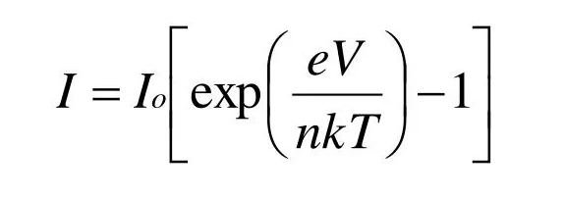
- I is the current flowing through the diode
- I0 is the dark saturation current,
- q is the charge on the electron,
- V is the voltage applied across the diode,
- η is the (exponential) ideality factor.
- is the Boltzmann constant
- T is the absolute temperature in Kelvin.

5 | What is effect of temperature on PN junction diode.
- PN junction diode parameters like reverse saturation current, bias current, reverse breakdown voltage and barrier voltage are dependent on temperature.
- Rise in temperature generates more electron-hole pair thus conductivity increases and thus increase in current.
- Increase in reverse saturation current with temperature offsets the effect of rise in temperature.
- Reverse saturation current (IS)(IS) of diode increases with increase in the temperature
6 | Define diffusion capacitance.
Diffusion capacitance occurs in a forward biased p-n junction diode. Diffusion capacitance is also sometimes referred as storage capacitance. It is denoted as CD.
The diffusion capacitance occurs due to stored charge of minority electrons and minority holes near the depletion region

7 | What is rectifier.
 | A rectifier is an electronic device used for converting alternating current to direct current with the help of one or more p-n junction diodes
8 | Draw the Clipper and Clamper waveforms.
 | 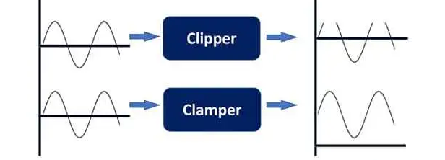
9 | Write the applications of LASER diodes
 | Fiber-optic communications, barcode readers, laser pointers, CD/DVD/Blu-ray disc reading/recording, laser printing, laser scanning and light beam illumination.
10 | What is the name of optoelectronic junction devices
- Light Emitting diodes – used for display, lighting, communication, remote control, etc.
- Laser Diodes – used for data storage, telecommunication.
- Photodiodes – used for telecommunication.
- Solar cells – used for energy conversion.

11 | What is tunnel diode and varactor diode.
The Varactor diode is a special case diode that is operated in reverse bias, where the junction capacitance is varied.
A Tunnel diode is a heavily doped PN junction diode in which electric current decreases as the voltage increases.
12 | What is drift and diffusion current.
The diffusion current can be defined as the flow of charge carriers within a semiconductor travels from a higher concentration region to a lower concentration region
Drift current can be defined as the charge carrier’s moves in a semiconductor because of the electric field.

